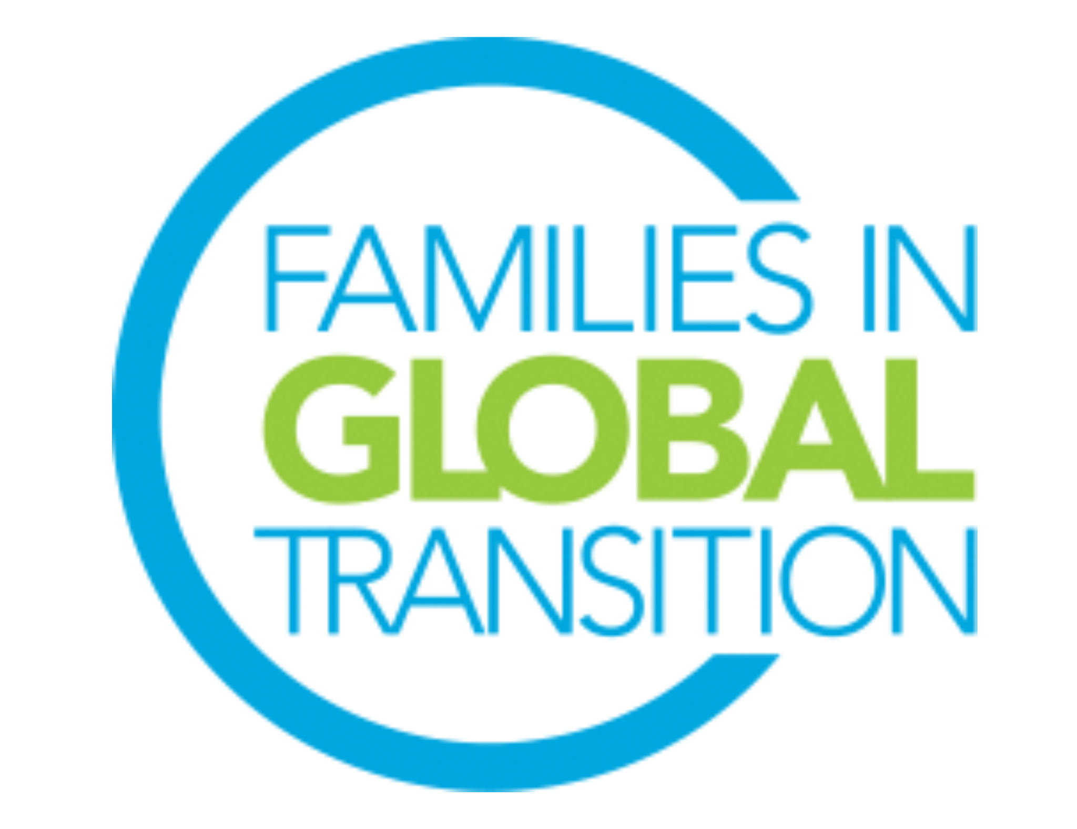
FIGT Development Director
Role Description

The FIGT Mission
Families in Global Transition (FIGT) is a caring community for the globally mobile where curiosity, connection, and collaboration happen.

Role Overview
The Development Director, with oversight from the FIGT Treasurer and input from the Executive Committee and other Board Members as applicable, will spearhead FIGT’s development efforts, oversee the organization’s long-term fundraising/sponsorship strategy and manage relationships with its financial partners.

The Development Director reports to the FIGT Treasurer.

Top Responsibilities and Tasks
- Collaborate with Board members to create and implement a long-term fundraising/ sponsorship plan, looking at all potential income streams.
- Explore the possibilities of financial partnerships with like-minded organizations and individuals.
- Plan and execute fundraising/sponsorship events.
- Secure financial support from individuals and organizations.
- Interact with former donors to encourage ongoing contributions.
- Seek out opportunities for financial support through grants and sponsorships.
- Identify, prospect for, and secure FIGT sponsors and exhibitors for the FIGT conference.
- Ensure sponsors’ privileges are provided, and that their concerns are taken into consideration in FIGT messaging and activities throughout the year.
- Other activities that promote the long-term financial sustainability of the organization.

Time Requirement
The Development Director must be flexible, be prepared to meet with donors and sponsors and answer queries across a wide variety of time zones as unexpected needs or concerns arise. The Development Director works an average of 15-30 hours monthly during the period of September through March (not including their attendance and work at the annual conference), with 10-15 hours monthly throughout the rest of the year. This includes preparation for, participation in, and follow-up to the monthly two-hour Global Board Meeting (GBM).

Please note: the time invested in this role may increase/decrease depending on the strategy and needs for each year and when the annual conference takes place. All Directors are expected to participate in the monthly 2-hour Board meetings (may require late or early morning calls).

Time Requirement (in hours per month)
Oct | Nov | Dec | Jan | Feb | March | April | May | June | July | Aug | Sept
15-30 | 15-30 | 15-30 | 15-30 | 15-30 | 15-30 | 10-15 | 10-15 | 10-15 | 10-15 | 10-15 | 15-30

Full term of office will commence on October 1, 2023 and end on September 30, 2025. We request that you are available from August onwards to start the onboarding process.

Critical Skills and Experiences
- Superb verbal and written communication skills
- Strong presentation skills to speak with donors and sponsors
- Strong strategic planning and analytical skills
- Meticulous attention to detail
- Good organizational and time management skills to keep projects on track
- Creative, self-starter attitude
- Fundraising/sponsorship, Sales, Marketing and/or Public Relations experience; working with/in businesses or organizations familiar with FIGT community-related topics and issues (e.g., multinational corporations, global mobility, international human resource sector, etc.) a plus

General Responsibilities & Requirements for all Board Directors
All Board Members are expected to be able to use Google Drive and WhatsApp and work in virtual environments, and be prepared to learn to use other online platforms. They are also expected to be able to help promote and network for the FIGT conference and FIGT membership, even if it is not a stated part of their role description.

- Must be a current FIGT member.
- Must have demonstrated commitment to and an understanding of FIGT through attending a previous conference, volunteering on a committee, or attendance at other FIGT events.
- Ability to commit up to 25 hours every month of volunteer work for this Board role.
- Attend the monthly virtual General Board Meetings. The General Board Meetings take place once a month and are two hours long. Meetings are across time zones and may require working at irregular and sometimes difficult hours. If needs arise there may be more than one each month.
- Attend the 2024 and 2025 Conferences, including the Board meetings which take place the day before and the day after the conference. Since FIGT is a volunteer-driven organization, it can only cover the conference registration fee for its Board members. Board members pay for travel to/from conference and accommodation at the conference (in-person conferences).
- Prior experience managing cross-cultural teams in diverse locations.
- Prior experience working online using collaborative platforms such as Google Drive, Zoom, WhatsApp, and Doodle.
- Available for on-boarding training during August and September 2023 (including attending the September General Board Meeting, meeting with predecessor for onboarding, chairing a committee meeting (if applicable), and meeting with Executive Committee members to whom the position reports (FIGT Treasurer).

