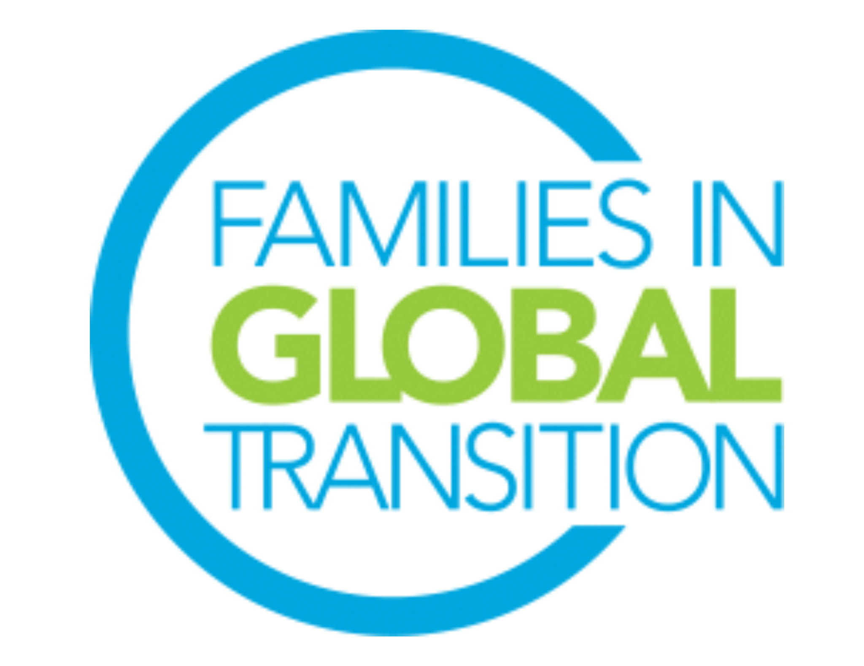
FIGT Affiliates Director
Role Description

The FIGT Mission
​Families in Global Transition (FIGT) is a welcoming forum for globally mobile individuals, families, and those working with them. We promote cross-sector connections for sharing research and developing best practices that support the growth, success and well-being of people crossing cultures around the world.

Role Overview
The purpose of FIGT Affiliates is to carry forward the global mission of promoting cross-sector connections for sharing research and developing best practices that support the growth, success, and well-being of people crossing cultures across the world. The Affiliates are organized to better serve people and organizations living and operating in specific regions, or around a topic of interest, such as Coaching & Counseling.

The Affiliates Director is tasked with providing leadership to the Affiliates Committee as well as recruiting, developing, and supporting Affiliate Leaders. The Families in Global Transitions Affiliates (or FIGT Affiliates) are defined as individual associations of people with common interest in the mission of FIGT. The Affiliates Director supports FIGT Affiliates in being a part of FIGT’s mission, vision, and core beliefs. The Affiliates Director, with the support of the Affiliates Committee, provides guidance, outreach, information, and leadership to Affiliates to ensure they are able to meet the Affiliate Guidelines throughout the year. The Affiliates Director serves as a voice for Affiliates on the FIGT Board of Directors by providing insights, updates, and feedback from the Affiliates leaders and Affiliate supporters.
The Affiliates Director reports to the FIGT Vice President.

Top Responsibilities and Tasks
- Serve as a focal point to all FIGT Affiliates including providing regular communication to Affiliate Leaders
- Provide leadership and guidance to the Affiliates Committee (currently 3 volunteers)
- Meet with the Affiliate Committee on a regular basis and support regional Affiliate meetings as required
- Develop, promote, and oversee FIGT Affiliates including the introduction of new Affiliates
- Ensure the FIGT Affiliate policies and bylaws are adhered to
- Review and take action as necessary once Annual Reports are complete
- Facilitate and lead FIGT Affiliate Global Leader meetings
- Respond to inquiries about FIGT Affiliates
- Advise FIGT Affiliate leaders on activities, meetings and resources
- Collaborate with FIGT Directors specifically: Membership, Communications, Nominations, and Sponsorship
- Update Communication Directors about Affiliates news, as required
- Fulfill monthly report for General Board Meeting

Time Requirement
Approximately 10-15 hours per month. Time commitment may fluctuate as needs arise. Anticipate increased time commitment as the annual FIGT conference approaches as often, interest in launching an FIGT Affiliate increases following an annual FIGT conference. The majority of work will be completely via email but anticipate time dedicated to video calls when needing to connect with an Affiliate.

Numbers below indicate how much time is spent each month on Affiliate duties. This does not include the amount of time taken to participate in monthly General Board Meetings and the additional time the Director might volunteer to help others’ work on the Board.

Please note: the time invested in this role may increase/decrease depending on the strategy and needs for each year and when the annual conference takes place. All Directors are expected to participate in the monthly 2-hour Board meetings (may require late or early morning calls).

Time Requirement (in hours per month)
Oct | Nov | Dec | Jan | Feb | March | April | May | June | July | Aug | Sept
15 | 10 | 10 | 15 | 10 | 20 | 10 | 15 | 15 | 10 | 15 | 15

Full term of office will commence on October 1, 2022 and end on September 30, 2024. We request that you are available from August onwards to start the onboarding process.

Critical Skills and Experience
- Ability to work virtually and across time zones
- Ability to provide leadership and guidance to Affiliate Committee & Affiliate Leaders
- Skilled in writing guidelines and policies for easy application/adoption in diverse situations
- Support problem solving and creativity when issues arise
- Excellent organizational skills
- Excellent interpersonal and leadership skills
- Experience of running or participating in an FIGT Affiliate is an asset
- Patience, flexibility, active listener, consensus-builder
- Outstanding skills to lead informally and align communications with other Board Directors such as Nominations, Membership, Sponsorship, and Research Network
- Comfort with diversity and fast moving change are essential

General Responsibilities & Requirements for all Board Directors
All Board Members are expected to be able to use Google Drive and WhatsApp and work in virtual environments. Board members have to be prepared to learn to use other online platforms if needed.They are also expected to be able to help promote and network for the FIGT conference and FIGT membership, even if it is not a stated part of their role description.

- Must be a current FIGT member.
- Must have attended an FIGT Annual Conference or volunteered for 12 months with an FIGT Committee.
- Ability to commit to 25+hours every month of volunteer work for Board position role
- Attend the monthly virtual General Board Meetings. The General Board Meetings take place once a month and are two hours long. Meetings are across time zones and may require working at irregular and sometimes difficult hours. If needs arise there may be more than one each month.
- Attend the 2023 and 2024 Conferences, including the Board meetings which take place the day before and the day after the conference. Since FIGT is a volunteer driven organization, it can only cover the conference registration fee for its Board members. Board members pay for travel to/from conference and accommodation at the conference (in-person conferences).
- Prior experience managing cross-cultural teams in diverse locations.
- Prior experience working online using collaborative platforms such as Google Drive, Zoom, WhatsApp, and Doodle.
- Available for on-boarding training during August and September 2022 (including attending the September General Board Meeting, meeting with predecessor, chairing a committee meeting (if applicable), and meeting with Executive Committee members to whom the position reports (FIGT Vice President).

