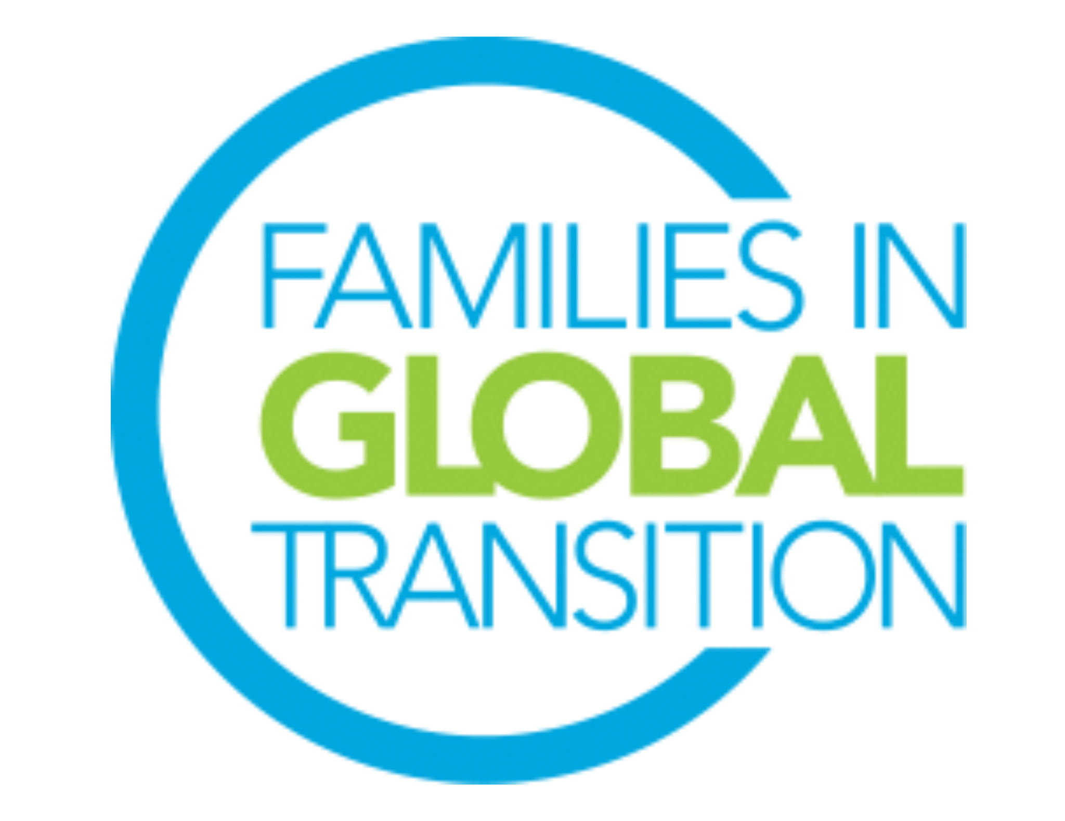
FIGT President
Role Description

The FIGT Mission
​Families in Global Transition is a welcoming forum for globally mobile individuals, families, and those working with them. We promote cross-sector connections for sharing research and developing best practices that support the growth, success and well-being of people crossing cultures around the world.

Role Overview
- The President is responsible for the overall management and oversight of the FIGT Board
- Presides at all meetings of the Board of Directors and the Executive Committee*
- Co-signs all promissory notes and contracts
- Appoints standing committee chairpersons and members
- Creates a special committee(s) as the need arises
- Serve as Ex-Officio of every committee
- Assume such other duties as may be assigned by the Board of Directors, or the Executive Committee

*The Executive Committee consists of the President, Vice-President, Executive Secretary and Treasurer.

Top Responsibilities and Tasks
- Develop and supervise strategic timelines and actions
- Set goals and objectives for the Board and ensure that they are met
- Develop external relationships that fulfill and enhance the organization’s mission
- Develop agendas for and chair General Board Meetings and Executive Committee Meetings
- Supervise assigned Board of Directors
- Supervise the Operations Lead

Time Requirement
Numbers below indicate how much time is spent each month. This does not include the amount of time taken to participate in monthly General Board Meetings and the additional time the Director might volunteer to help others’ work on the Board.

Please note: the time invested in this role may increase/decrease depending on the strategy and needs for each year and when the annual conference takes place. All Directors are expected to participate in the monthly 2-hour Board meetings (may require late or early morning calls).

Time Requirement (in hours per month)
Oct | Nov | Dec | Jan | Feb | Mar | April | May | June | July | Aug | Sept
30 | 30 | 35 | 40 | 45 | 40 | 25 | 25 | 25 | 20 | 20 | 25

Full term of office will commence on October 1, 2022 and end on September 30, 2024. We request that you are available from August onwards to start the onboarding process.

Critical Skills and Experience
- Ability to see a big picture and be able to communicate it well
- Strong team leadership skills and previous team management experience
- Comfort with conflict and proven conflict-resolution skills
- Have a broad network
- Strong networking skills
- Be approachable, open and an active listener
- Capable of setting priorities when multiple demands are present
- Be a strategist with long-term vision
- Be knowledgeable about the organization and its mission
- Comfort with diversity and fast moving change are essential
- Strong iInterpersonal skills with cross-cultural sensitivity
- Ability to work virtually and across time zones
- Previous experience with Board leadership preferred

General Responsibilities & Requirements for all Board Directors
All Board Members are expected to be able to use Google Drive and WhatsApp and work in virtual environments. Board members have to be prepared to learn to use other online platforms if needed. They are also expected to be able to help promote and network for the FIGT conference and FIGT membership, even if it is not a stated part of their role description.

- Must be a current FIGT member.
- Must have attended an FIGT Annual Conference or volunteered for 12 months with an FIGT Committee.
- Ability to commit to 25+hours every month of volunteer work for Board position role
- Attend the monthly virtual General Board Meetings. The General Board Meetings take place once a month and are two hours long. Meetings are across time zones and may require working at irregular and sometimes difficult hours. If needs arise there may be more than one each month.
- Attend the 2023 and 2024 Conferences, including the Board meetings which take place the day before and the day after the conference. Since FIGT is a volunteer driven organization, it can only cover the conference registration fee for its Board members. Board members pay for travel to/from conference and accommodation at the conference (in-person conferences).
- Prior experience managing cross-cultural teams in diverse locations.
- Prior experience working online using collaborative platforms such as Google Drive, Zoom, WhatsApp, and Doodle.
- Available for on-boarding training during August and September 2022 (including attending the September General Board Meeting, meeting with predecessor, chairing a committee meeting (if applicable), and meeting with Executive Committee members.

