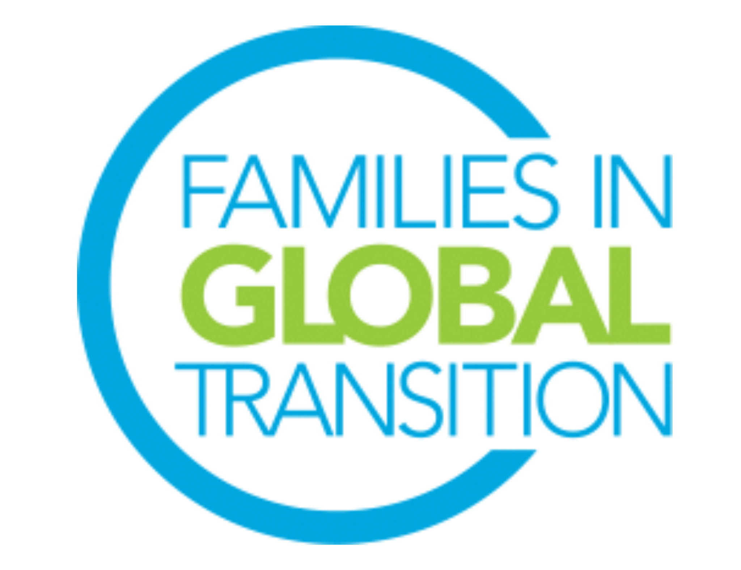
FIGT Research and Education Director
Role Description

The FIGT Mission
​Families in Global Transition is a welcoming forum for globally mobile individuals, families, and those working with them. We promote cross-sector connections for sharing research and developing best practices that support the growth, success and well-being of people crossing cultures around the world.

Role Overview
The role of the Research and Education Director (RED) is to create and maintain relationships between FIGT, and research and educational institutions and organizations. The RED, with the support of the FIGT Research Network (FRN) Committee, helps to ensure that the annual Conference program reflects historic, recent, ongoing and planned research relevant to FIGT membership, conference attendees, and those who support them. This role serves as the chair of the FIGT Research Network Committee. The RED provides guidance and oversight of the FRN Committee to maintain adherence to FIGT’s mission, values, policies and procedures.

Top Responsibilities and Tasks
● Create and maintain partnerships with research and educational institutions and connect with individual researchers and educators working in FIGT’s fields of interest.
● Recruit FRN Committee members.
● Regularly attend and co-chair FRN Committee meetings.
● Serve as the FIGT Board’s voice for sustaining research credibility and presence in the research representation at the FIGT annual conference and in FIGT events throughout the year.
● Attract researchers and educators working in FIGT’s fields of interest to become members
● Prepare for and attend the monthly FIGT Board meeting
● Follow up with FIGT Board Directors each month
Time Requirement
Numbers below indicate how much time is spent each month on RED duties. This does not include the amount of time taken to participate in general Board meetings and the additional time the Director might volunteer to help others’ work on the Board.

Please note: the time invested in this role may increase/decrease depending on the strategy and needs for each year and when the annual conference takes place. All Directors are expected to participate in the monthly 2-hour Board meetings (may require late or early morning calls).

Time Requirement (in hours per month)
Nov | Dec | Jan | Feb | March | April | May | June | July | Aug | Sept | Oct
10 | 10 | 10 | 10 | 15 | 15 | 10 | 5 | 5 | 5 | 5 | 5

Top Skills and Experience
● Networking skills
● Strong interpersonal skills with cross-cultural sensitivity
● Willingness to work with individuals from different time zones, including during weekends.
●Current or previous work within the field of research, preferably with personal experience in both academic and research fields, with a proven track record (publication in academic journals and citation)
● Strong organization skills
● Able to craft a long-term vision for the role
● Meticulous planning skills and attention to detail
● Ability to work with others and to resolve conflicts with patience and diplomacy
- Attentive to others - including ability to support presenters and other community members who may require your time
● Strong understanding of FIGT mission/goals as reflected through the annual conference program

General Responsibilities & Requirements for all Board Directors
All Board Members are expected to be able to use Google Drive and WhatsApp and work in virtual environments. Board members have to be prepared to learn to use other online platforms if needed. They are also expected to be able to help promote and network for the FIGT conference and FIGT membership, even if it is not a stated part of their role description.

- Must be a current FIGT member.
- Must have attended an FIGT Annual Conference or volunteered for 12 months with an FIGT Committee.
- Ability to commit to 25+hours every month of volunteer work for Board position role
- Attend the monthly virtual General Board Meetings. The General Board Meetings take place once a month and are two hours long. Meetings are across time zones and may require working at irregular and sometimes difficult hours. If needs arise there may be more than one each month.
- Attend the 2023 and 2024 Conferences, including the Board meetings which take place the day before and the day after the conference. Since FIGT is a volunteer driven organization, it can only cover the conference registration fee for its Board members. Board members pay for travel to/from conference and accommodation at the conference (in-person conferences).
- Prior experience managing cross-cultural teams in diverse locations.
- Prior experience working online using collaborative platforms such as Google Drive, Zoom, WhatsApp, and Doodle.
- Available for on-boarding training during August and September 2022 (including attending the September General Board Meeting, meeting with predecessor, chairing a committee meeting (if applicable), and meeting with Executive Committee members to whom the position reports.

